**SAMPLE SCREEN SHOTS**

**Home Page**

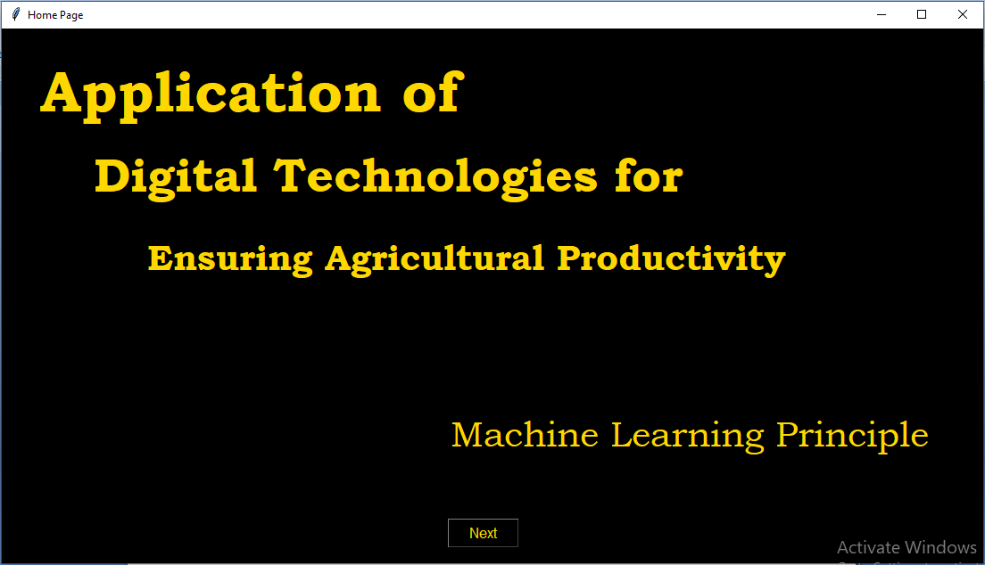

**ADMIN CONTROL**

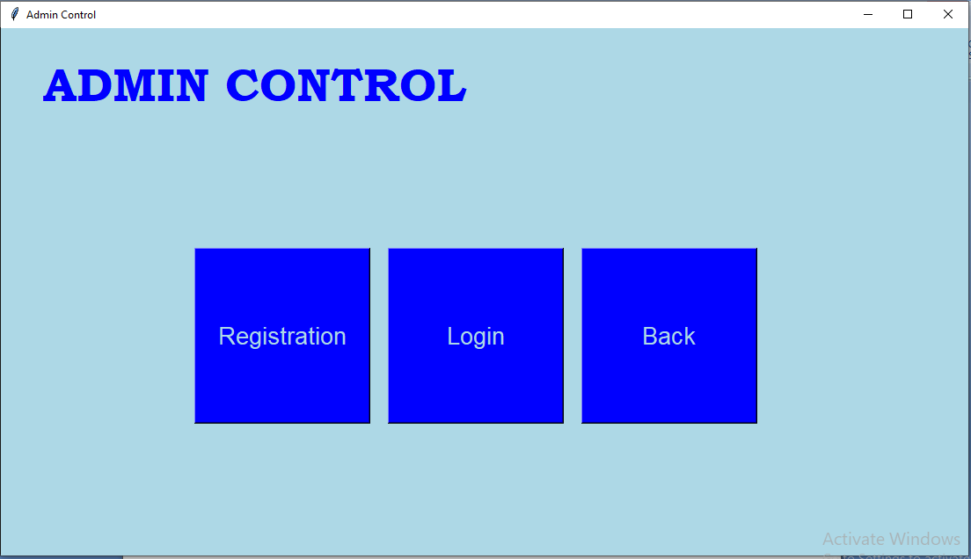

**REGISTRATION DASH-BOARD**

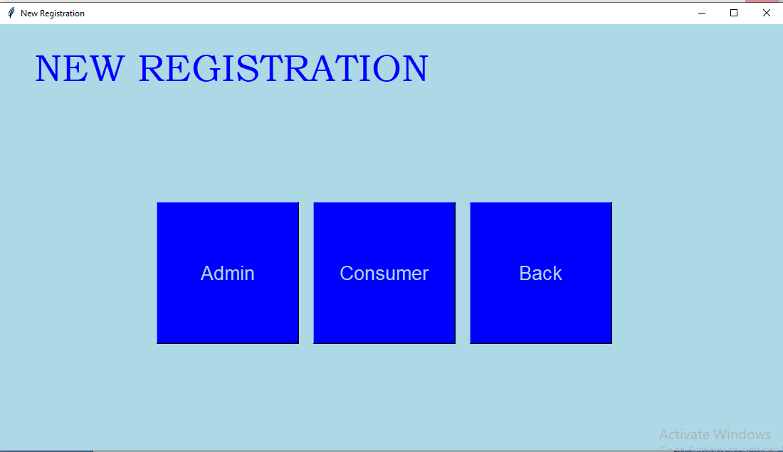

**ADMIN REGISTRATION**

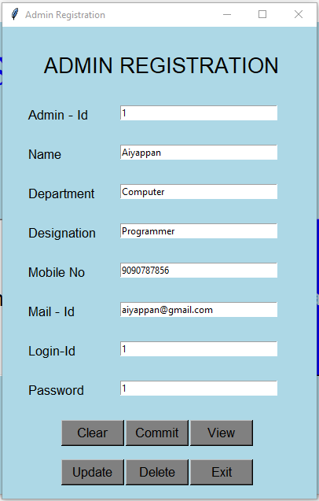

**CONSUMER REGISTRATION**

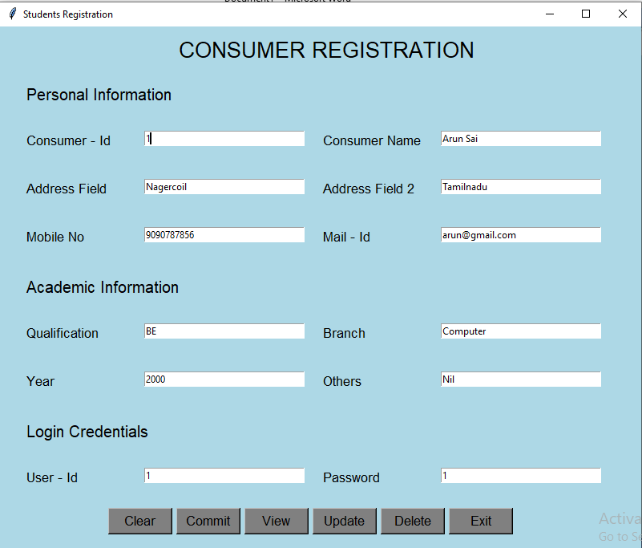

**LOGIN CONTROL PANEL**

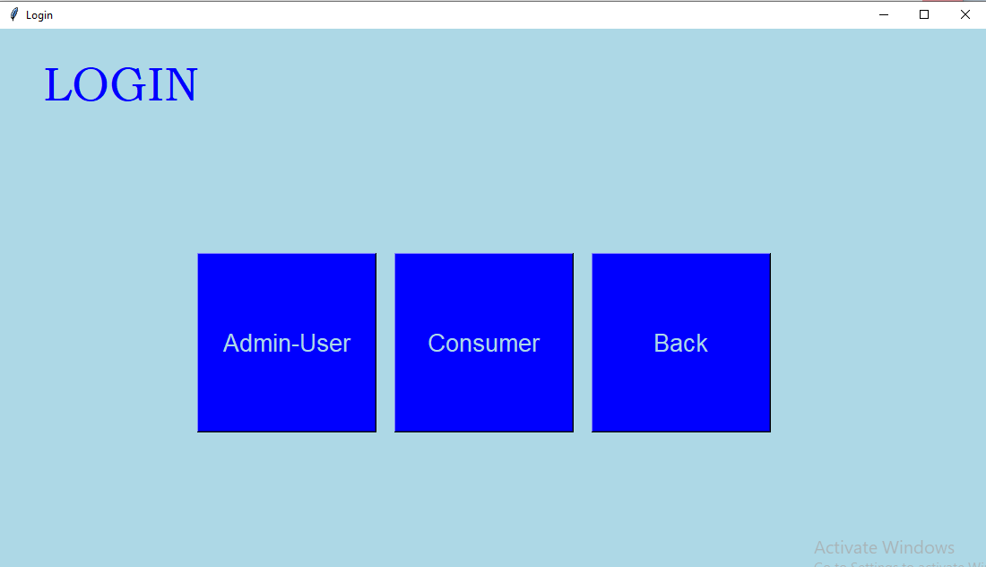

**ADMIN LOGIN**

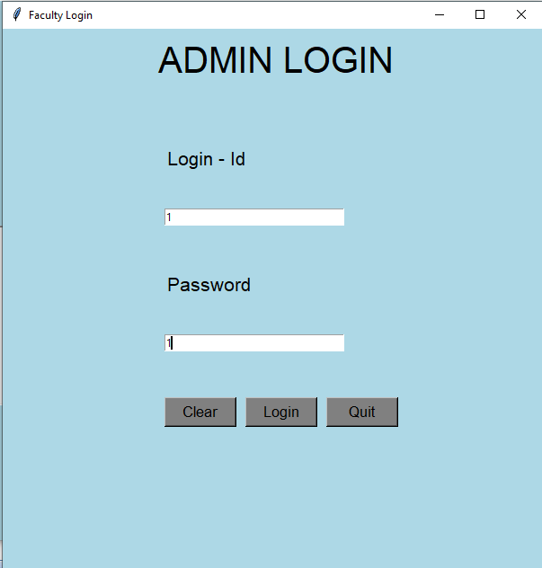

**ADMIN DATA PROCESS CENTER**

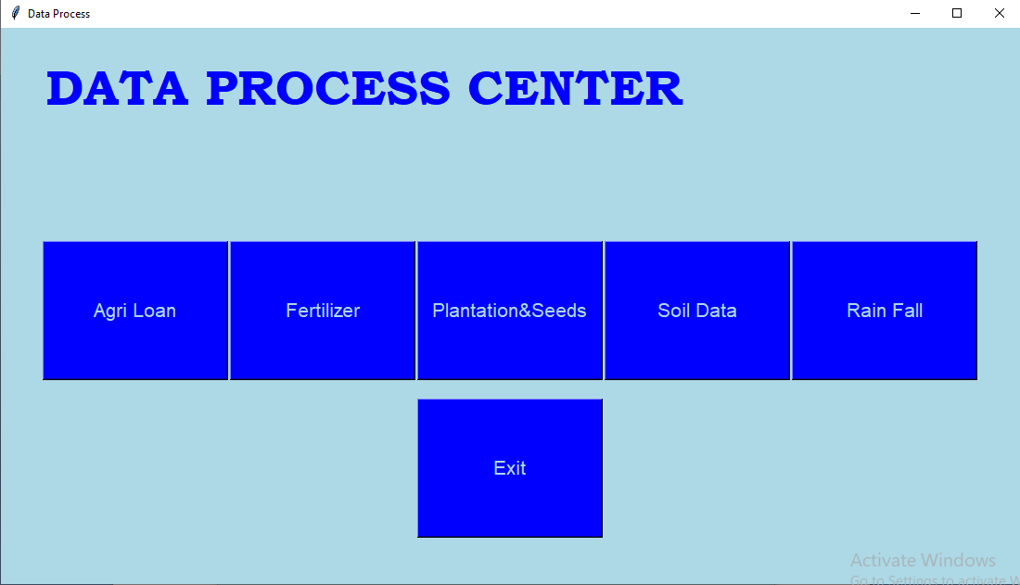

**SAMPLE AGRI LOAN DATA**

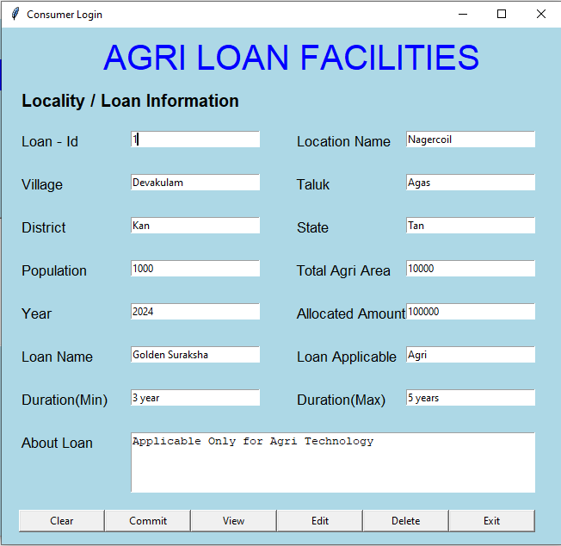

**SAMPLE FERTILIZER DATA**

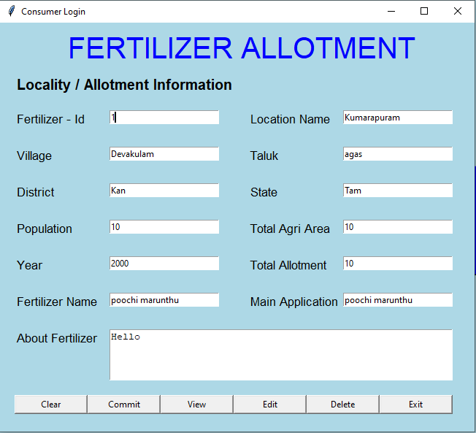

**PLANTATION SAMPLE DATA**

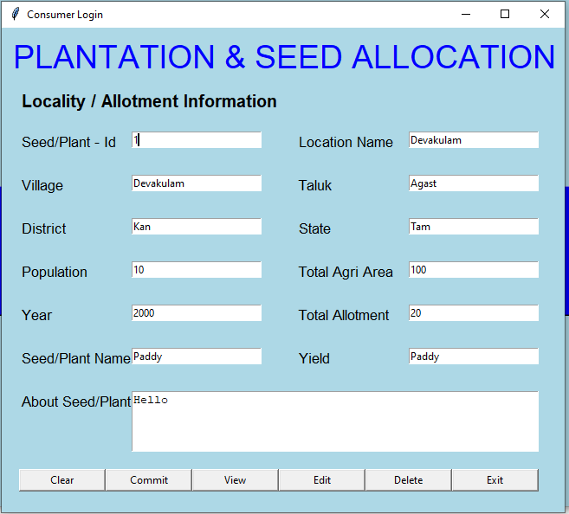

**RAIN FALL SAMPLE DATA**

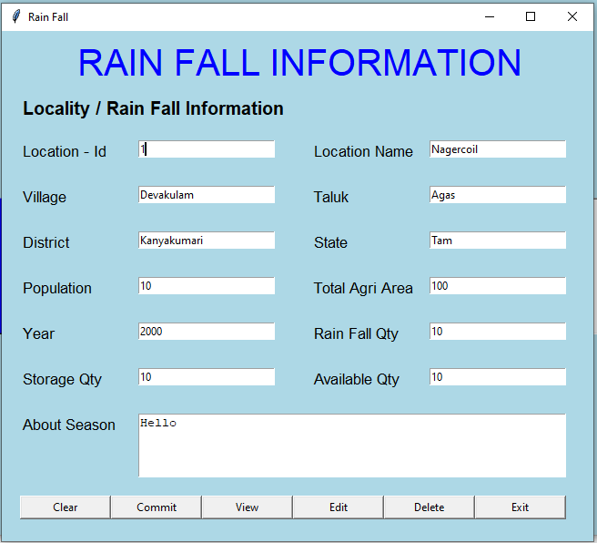

**CONSUMER LOGIN**

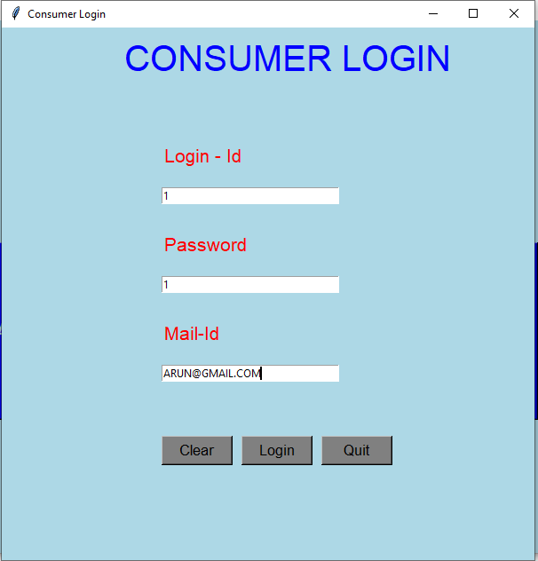

**CONSUMER QUERY PROCESS CENTER**

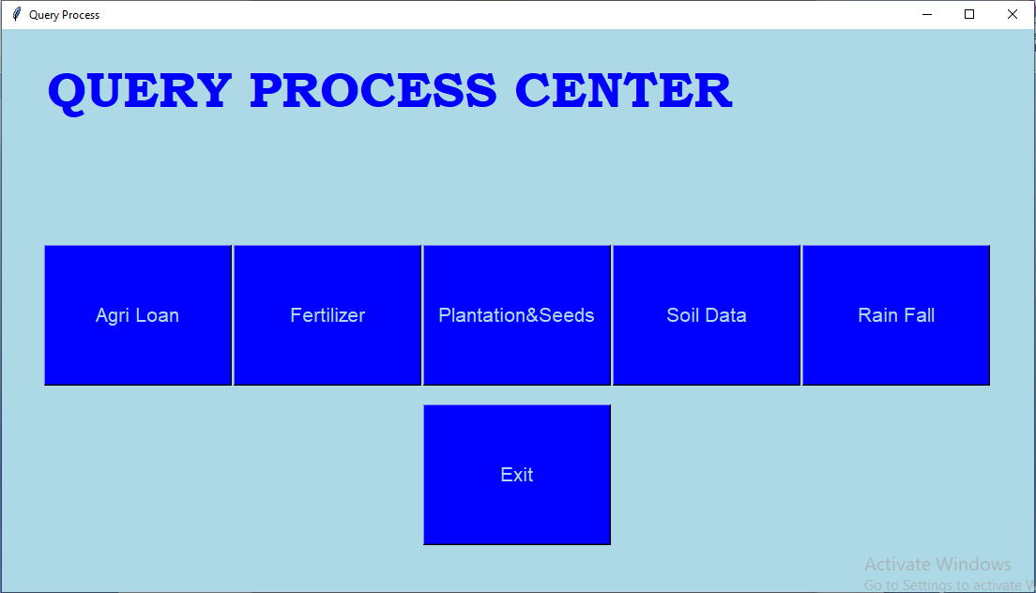

**AGRI LOAN QUERY PROCESS CENTER**

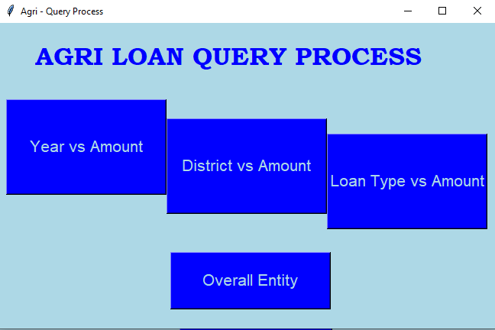

**OVERALL ENTITY**

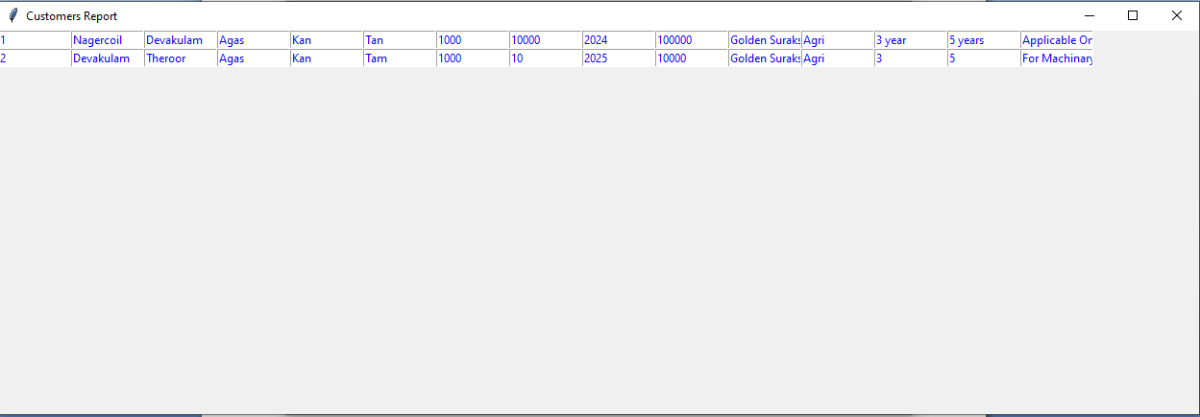

**AMOUNT VS YEAR**

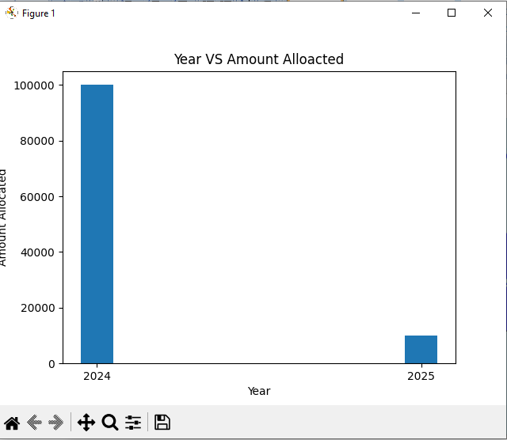

**DISTRICT VS AMOUNT**

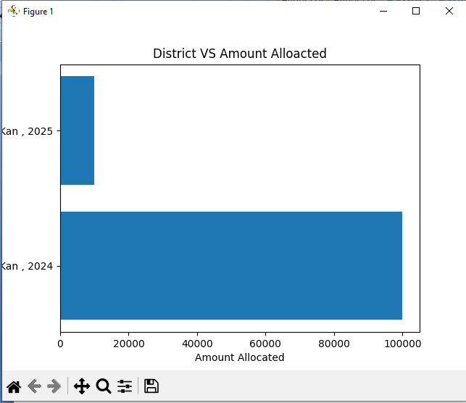

**LOAN TYPE VS AMOUNT**

